Test Plan

**ID**: Registration 011

**Scope**

Validate Liferay registration feature. Make sure customer able to register successfully.

**Risk**

Performance. Software needs to be able to manage high level of user load.

**Acceptance criteria**

1. User is able to register successfully in English providing name, date of birth and testing area answer.
2. Software needs to handle mandatory fields. All entry field is mandatory.

No high and medium priority bug in the backlog.

**Feature not to be tested**

Registration in Portuguese language is not in scope for this release.

**Environments**

Test environment and UAT with masked real data.

**Resources**

VV Project manager

UH Test lead/manager

XY test automation engineer

XZ manual ester

**Test strategy and technic**

**-Testing registration functionality (E2E)**

**- Testing entry field validation**

**- Non functional testing: Layout, design, performance, usability, security**

**- Automate test cases for registration functionality as a smoke test (happy cases) for running at each commitment.**

**Deadlines**

* **Feature freeze, code freeze, release etc**

**Test deliverables**

* **Test design.**
* **Create E2E test cases for registration feature and mark these for regression (including green and red cases)**
* **Create test cases for entry field validation (including edge cases)**
* **Report bugs**
* **Perform manual test execution**
* **Implement automated test with generated reports (integrated into CI/CD)**
* **Provide bug report, status report, quality matrix about the product**
* **Retest bug fixes**
* **Cross browser testing on supported browsers**
* **Approve requirements**

**Test report design**

**Componenet of a bug report that need to be provided by tester:**

* **Title**
* **Status (opened by default)**
* **Assignee (dev managed by default)**
* **Description (explain the bug with details)**
* **Environment**
* **Release/Version**
* **Priority (high/medium/low)**
* **Severity (high/medium/low)**
* **Steps to replicate**
* **Actual result**
* **Excepted result**
* **Attachment (logs/screenshots)**
* **Reporter (automatic)**
* **Link (assign to a requirement)**

Bug Report

1.

* **Title: Mandatoriness validation is applied when user click away from an entry field**
* **Status: Opened**
* **Assignee: XY**
* **Description: Clicking away user action triggers the mandatoriness entry field validation**
* **Environment: QA env**
* **Release/Version: 1.1.34**
* **Priority (high/medium/low): Medium**
* **Severity (high/medium/low): Low**
* **Steps to replicate: Clicking in any empty entry field and clicking away without any typing the field will be validated and message shown up : „**This field is required.”
* **Actual result: „**This field is required” warning is shown u pin red
* **Excepted result: Mandatoriness validation should not be applied/treiggered. That should be triggered only for clicking Submit button**
* **Attachment (logs/screenshots)**
* 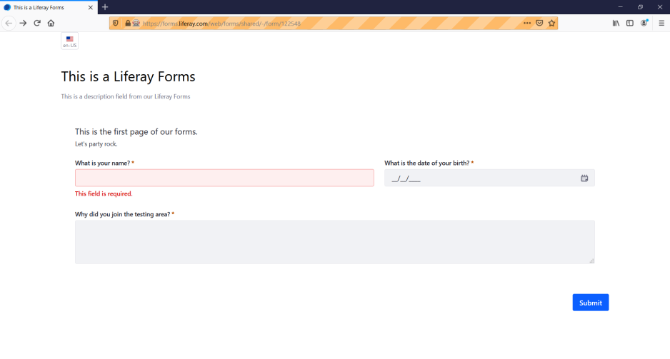
* **Reporter (automatic): Tester**
* **Link (assign to a requirement): Requirement: 12345 – Registration process**

2.

* **Innecessary message at the end of registration: „Information sent”**

3.

- Wrong title for success registration page: „Form – Forms”

4.

- User can register with date of birth in future.

5.

- Date-picker: User is not able to select year more than 5 years down by default

6.

- Submit button is not aligned to entry fields